Machine Learning-Based Prediction of Superconducting Critical Temperature Using Material Descriptors

Research Project Report

Prepared by

Kaveri Yadav

Master of Science in Physics
Degree Awarded: June 2026

Independent Research Project

July 2026

Abstract
The discovery of novel superconducting materials remains one of the most significant challenges in condensed matter physics and materials science. Superconductors exhibit zero electrical resistance below a characteristic critical temperature (Tc), making them indispensable for applications in energy transmission, magnetic resonance imaging (MRI), particle accelerators, quantum computing, and magnetic levitation systems. However, conventional experimental approaches for identifying new superconducting materials require extensive laboratory investigations, making the discovery process expensive, time-consuming, and resource-intensive.
Recent advances in machine learning have provided powerful computational techniques for accelerating materials discovery by learning complex relationships between experimentally measured material properties and their corresponding physical behavior. Data-driven predictive models enable researchers to estimate important material characteristics without performing exhaustive laboratory experiments, thereby reducing both time and experimental cost.
This project presents a machine learning framework for predicting the superconducting critical temperature using the UCI Superconductivity Dataset containing 21,263 superconducting materials described by 81 experimentally measured material descriptors. Four supervised machine learning regression models - Linear Regression, Random Forest Regression, Tuned Random Forest, and Extreme Gradient Boosting (XGBoost)—were developed and systematically compared.
The predictive performance of each model was evaluated using Mean Absolute Error (MAE), Root Mean Squared Error (RMSE), and the coefficient of determination (R² Score). Among the evaluated models, the optimized Random Forest achieved the highest predictive performance with an R² Score of 0.9289, demonstrating its ability to effectively model the nonlinear relationships between material descriptors and superconducting critical temperature.
To improve model transparency and interpretability, SHapley Additive exPlanations (SHAP) were employed to identify the most influential material descriptors contributing to the model's predictions. The explainability analysis revealed that thermal conductivity, atomic mass, density, and valence-related descriptors play dominant roles in determining superconducting behavior.
The results demonstrate that ensemble learning methods combined with explainable artificial intelligence provide an effective computational framework for predicting superconducting critical temperature while simultaneously improving the interpretability of machine learning models used in materials science.

Keywords
Machine Learning, Superconductivity, Critical Temperature, Random Forest, XGBoost, Explainable Artificial Intelligence, SHAP, Materials Informatics, Computational Physics, Regression Analysis.

Table of Contents

- Introduction
- Literature Background
- Objectives
- Dataset Description
- Methodology
5.1 Data Collection
5.2 Data Preprocessing
5.3 Exploratory Data Analysis
5.4 Linear Regression
5.5 Random Forest Regression
5.6 Hyperparameter Optimization
5.7 XGBoost Regression
5.8 Model Evaluation
- Experimental Results
- Explainable Artificial Intelligence using SHAP
- Discussion
- Conclusion
- Future Work
- References

1. Introduction
Superconductivity is one of the most remarkable quantum phenomena observed in condensed matter physics. First discovered by Heike Kamerlingh Onnes in 1911, superconductivity is characterized by the complete disappearance of electrical resistance below a material-specific critical temperature (Tc). In addition to zero electrical resistance, superconductors exhibit the Meissner effect, in which magnetic fields are expelled from the interior of the material, making superconductors fundamentally different from ordinary conductors.
Superconducting materials have attracted significant scientific and industrial interest because of their ability to transmit electrical current without energy loss. Their unique physical properties have enabled numerous technological applications, including superconducting magnets for Magnetic Resonance Imaging (MRI), particle accelerators, magnetic levitation transportation systems, fusion reactors, quantum computing devices, and highly efficient power transmission networks. As technological demands continue to increase, the discovery of superconductors with higher critical temperatures remains a major objective in materials science research.
Despite decades of experimental investigations, discovering new superconducting materials remains an extremely challenging task. The superconducting behavior of a material depends on complex interactions among its chemical composition, atomic structure, electronic configuration, and thermodynamic properties. Experimental synthesis and characterization of candidate materials require sophisticated laboratory equipment, significant financial investment, and considerable research time. Consequently, conventional trial-and-error approaches are inefficient for exploring the vast space of possible material compositions.
The emergence of machine learning has transformed many areas of scientific research by enabling computers to identify complex nonlinear relationships directly from experimental data. Rather than relying solely on theoretical models or exhaustive experimentation, machine learning algorithms can learn predictive relationships from previously observed data and estimate material properties with high accuracy. In recent years, machine learning has become an increasingly important tool in computational materials science, assisting researchers in accelerating material discovery, optimizing experimental design, and identifying promising candidate materials for further investigation.
In this project, machine learning techniques are employed to predict the superconducting critical temperature using experimentally measured material descriptors obtained from the UCI Superconductivity Dataset. Four regression algorithms—Linear Regression, Random Forest, Tuned Random Forest, and XGBoost—are implemented and systematically evaluated. Their predictive performances are compared using widely accepted regression evaluation metrics, including Mean Absolute Error (MAE), Root Mean Squared Error (RMSE), and the coefficient of determination (R²).
In addition to achieving high predictive accuracy, model interpretability is considered an essential aspect of this study. Ensemble learning models often function as "black-box" predictors, making it difficult to understand the factors influencing their predictions. To address this challenge, SHapley Additive exPlanations (SHAP) are employed to quantify the contribution of individual material descriptors to the predicted critical temperature. This explainability analysis provides valuable scientific insight into the material properties governing superconductivity while increasing confidence in the predictive capability of the developed models.
Overall, this project demonstrates how modern machine learning techniques can complement traditional experimental methods by providing efficient, interpretable, and accurate predictive models for superconducting materials, thereby contributing to the broader field of computational materials discovery.

2. Literature Review
The integration of machine learning with materials science has emerged as one of the most rapidly developing areas of computational research. Advances in data availability, computational power, and artificial intelligence have enabled researchers to analyze complex material systems using data-driven approaches rather than relying exclusively on conventional theoretical or experimental methods.
Several recent studies have demonstrated that ensemble learning algorithms, including Random Forest and Gradient Boosting methods, consistently outperform traditional statistical models when predicting material properties (Breiman, 2001; Chen & Guestrin, 2016). These models effectively capture nonlinear interactions among material descriptors and have been successfully applied to problems such as crystal structure prediction, alloy design, thermal conductivity estimation, and superconducting critical temperature prediction.
Explainable Artificial Intelligence (XAI) has also become increasingly important in scientific machine learning. While highly accurate predictive models are valuable, understanding the reasoning behind their predictions is equally essential for scientific discovery. SHapley Additive exPlanations (SHAP) provide a mathematically rigorous framework for interpreting machine learning models by quantifying the contribution of each input feature to individual predictions (Lundberg & Lee, 2017). This capability enables researchers to identify the most influential material descriptors while improving confidence in the model's predictive behavior.
Recent developments in materials informatics have further strengthened the application of machine learning in condensed matter physics. By integrating experimental databases with advanced computational algorithms, researchers can efficiently screen thousands of candidate materials and identify promising superconductors prior to experimental synthesis. This data-driven approach complements traditional theoretical and experimental methods by reducing the time, cost, and experimental effort required for materials discovery. Consequently, machine learning has become an important tool for accelerating research in computational materials science (Pedregosa et al., 2011).
Building upon these recent advances, the present study integrates ensemble learning algorithms with Explainable Artificial Intelligence (XAI) to develop an accurate and interpretable framework for predicting the superconducting critical temperature. By combining high predictive performance with model interpretability, this work contributes to the growing field of computational materials science and materials informatics.

3. Objectives
The primary objectives of this research project are:
- To analyze the UCI Superconductivity Dataset using exploratory data analysis techniques.
- To preprocess the dataset for machine learning model development.
- To develop a baseline Linear Regression model for comparison.
- To implement Random Forest Regression for nonlinear prediction.
- To improve Random Forest performance through hyperparameter optimization.
- To develop an XGBoost regression model for comparative analysis.
- To evaluate all models using MAE, RMSE, and R² Score.
- To compare the predictive performance of all machine learning models.
- To interpret the best-performing model using SHAP explainability.
- To demonstrate the potential of machine learning for accelerating superconducting materials research.

4. Dataset Description
The dataset used in this study is the **Superconductivity Dataset** obtained from the **UCI Machine Learning Repository**, a widely recognized repository for machine learning research datasets. The dataset contains experimentally measured material descriptors collected from a large number of known superconducting materials. These descriptors represent various physical and chemical properties that influence the superconducting critical temperature (Tc).
The dataset consists of 21,263 observations, each representing a superconducting material, each described by **81 numerical material descriptors**, with the superconducting critical temperature (Tc) serving as the target variable. The descriptors include statistical measures of atomic mass, atomic radius, density, thermal conductivity, electron affinity, valence electrons, fusion heat, atomic volume, and several other elemental properties that collectively characterize each material.
Since the dataset contains only numerical variables and no categorical attributes, it is well suited for regression-based machine learning algorithms. Furthermore, the relatively large number of observations provides sufficient information for training complex ensemble learning models while minimizing the risk of overfitting.
The objective of this study is to learn the relationship between these experimentally measured material descriptors and the superconducting critical temperature so that the critical temperature of previously unseen materials can be accurately predicted.

Characteristic | Description
Dataset | UCI Superconductivity Dataset
Source | UCI Machine Learning Repository
Number of Samples | 21,263
Number of Features | 81
Target Variable | Critical Temperature (Tc)
Learning Task | Supervised Regression
Feature Type | Numerical Material Descriptors
Table 1. Summary of the Superconductivity Dataset

The large size and diversity of this dataset make it suitable for evaluating both conventional statistical models and modern machine learning algorithms.

5. Methodology
This chapter describes the complete machine learning workflow adopted for predicting the superconducting critical temperature. The methodology consists of data preprocessing, exploratory data analysis, model development, hyperparameter optimization, model evaluation, and explainable artificial intelligence techniques.

The overall workflow followed in this project is illustrated below:

Dataset Collection
↓
Data Preprocessing
↓
Exploratory Data Analysis
↓
Train-Test Split
↓
Model Development
↓
Hyperparameter Optimization
↓
Model Evaluation
↓
Model Comparison
↓
SHAP Explainability

5.1 Data Collection
The superconductivity dataset was downloaded from the UCI Machine Learning Repository. The dataset contains experimentally measured physical and chemical descriptors corresponding to superconducting materials. Each observation represents one superconducting compound, while each feature describes a measurable property of the material.
The dataset was imported into Python using the Pandas library, enabling efficient manipulation and analysis throughout the machine learning workflow.

5.2 Data Preprocessing
Data preprocessing is one of the most important stages in any machine learning project because the quality of the input data directly influences the predictive performance of the developed models.
Initially, the dataset was inspected to examine its structure, dimensions, data types, and statistical properties. Missing values were checked to ensure that incomplete observations would not affect model training. Since the selected dataset was already well curated, no significant missing values requiring imputation were observed.
The dataset was then divided into input features and the target variable. The material descriptors were treated as independent variables, while the superconducting critical temperature (Tc) was considered the dependent variable.
Finally, the dataset was divided into training and testing subsets using an 80:20 ratio. The training dataset was used for model development, whereas the testing dataset was reserved exclusively for evaluating predictive performance on previously unseen samples.

5.3 Exploratory Data Analysis (EDA)
Exploratory Data Analysis was performed to understand the statistical characteristics of the dataset before developing predictive models.
The initial analysis included inspection of the dataset dimensions, feature names, summary statistics, and data types. Histograms and scatter plots were generated to visualize the distribution of the superconducting critical temperature and investigate relationships between selected material descriptors and Tc.
The distribution of Tc revealed that superconducting materials exhibit a wide range of critical temperatures, with a large concentration of observations occurring at relatively lower temperatures and fewer materials exhibiting high Tc values.
Scatter plots between mean atomic mass and critical temperature demonstrated nonlinear relationships, indicating that advanced ensemble learning algorithms would likely outperform simple linear models.
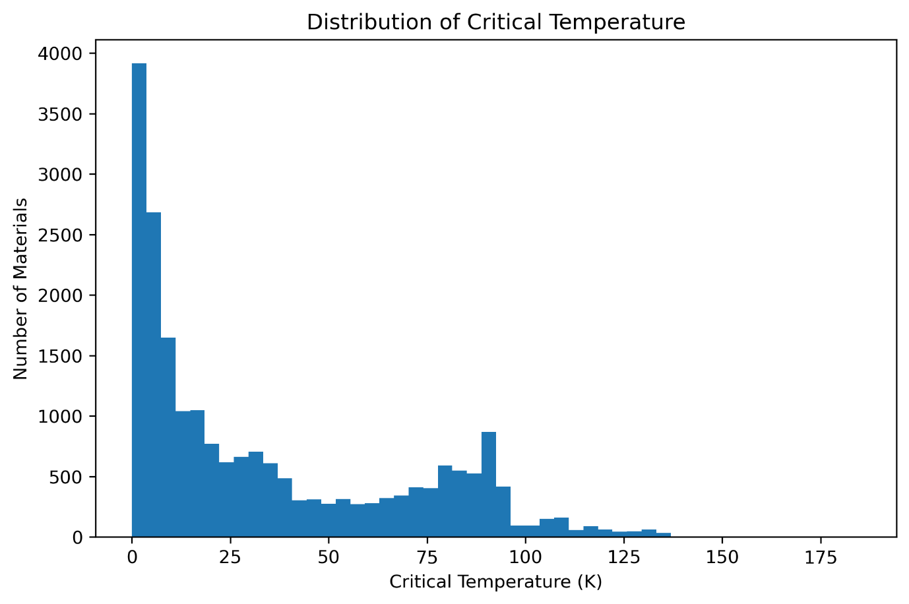
The exploratory analysis provided valuable insight into the overall structure of the dataset and motivated the selection of nonlinear regression algorithms.
Figure 1. Distribution of Superconducting Critical Temperature.

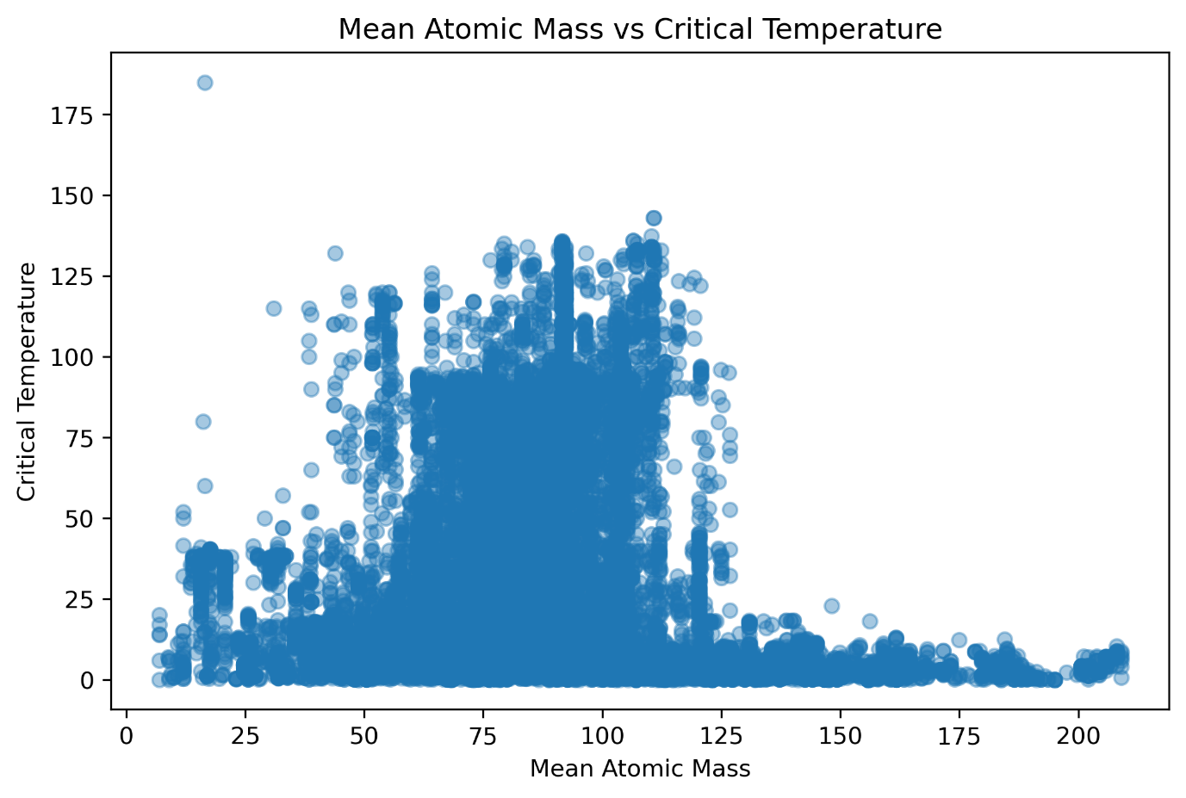
Figure 2. Relationship between Mean Atomic Mass and Critical Temperature.
5.4 Linear Regression
Linear Regression was implemented as the baseline predictive model for this study. It assumes a linear relationship between the input features and the target variable by fitting a linear equation that minimizes the sum of squared prediction errors.
The model was trained using the training dataset and evaluated using the testing dataset. Although Linear Regression is computationally efficient and highly interpretable, its assumption of linearity limits its ability to capture the complex nonlinear interactions among material descriptors.
The results obtained from Linear Regression provide a useful benchmark against which more sophisticated machine learning algorithms can be compared.

5.5 Random Forest Regression
Random Forest Regression is an ensemble learning algorithm that combines the predictions of multiple decision trees to improve predictive accuracy and reduce overfitting.
Each decision tree is trained using a randomly selected subset of observations and predictor variables. The final prediction is obtained by averaging the predictions of all individual trees.
Compared with Linear Regression, Random Forest is capable of learning highly nonlinear relationships between material descriptors and superconducting critical temperature, making it particularly suitable for complex materials datasets.
Feature importance scores were also extracted from the trained Random Forest model to identify the most influential material descriptors affecting superconducting critical temperature.
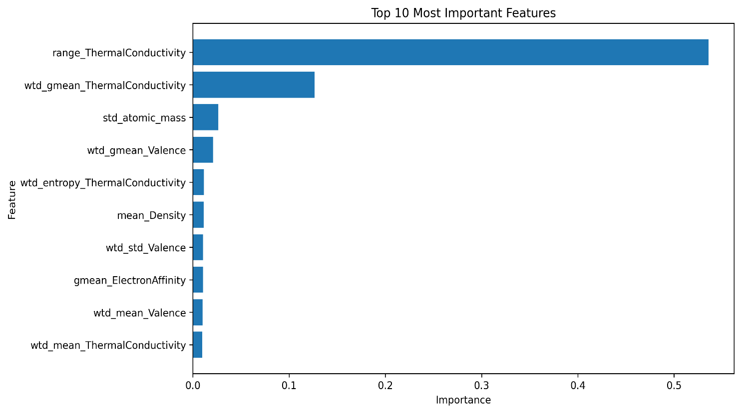
Figure 3. Random Forest Feature Importance.

5.6 Hyperparameter Optimization
Although the baseline Random Forest model produced strong predictive performance, its accuracy depends on several hyperparameters that control model complexity and tree construction.
To further improve predictive performance, hyperparameter optimization was performed using RandomizedSearchCV. Multiple combinations of model parameters, including the number of trees, maximum tree depth, minimum samples required for node splitting, and minimum samples required at leaf nodes, were evaluated through cross-validation.
The optimized Random Forest model demonstrated a slight improvement in predictive performance while maintaining strong generalization capability on unseen test data.

5.7 XGBoost Regression
Extreme Gradient Boosting (XGBoost) is an advanced ensemble learning algorithm based on gradient boosting decision trees. Unlike Random Forest, which builds trees independently, XGBoost constructs trees sequentially, allowing each new tree to correct the prediction errors of previous trees.
XGBoost incorporates regularization techniques that improve generalization while reducing the risk of overfitting. Owing to its computational efficiency and predictive capability, XGBoost has become one of the most widely used algorithms for regression and classification tasks.
The XGBoost model was trained using the same training dataset and evaluated using identical performance metrics to ensure a fair comparison with the other regression models.

5.8 Model Evaluation Metrics
The predictive performance of all regression models was evaluated using three widely accepted regression metrics.
Mean Absolute Error (MAE) measures the average absolute difference between predicted and actual critical temperature values. Lower MAE values indicate better predictive accuracy.
Root Mean Squared Error (RMSE) measures the square root of the average squared prediction error. Because larger errors receive greater penalties, RMSE provides a more sensitive measure of prediction quality.
The coefficient of determination (R² Score) measures the proportion of variance in the target variable explained by the predictive model. An R² value closer to one indicates superior predictive performance.
These evaluation metrics provide complementary perspectives for comparing the performance of the developed machine learning models and selecting the most appropriate predictive algorithm.

6. Experimental Results
This chapter presents the performance of all developed machine learning models for predicting the superconducting critical temperature (Tc). The models were evaluated on the testing dataset using Mean Absolute Error (MAE), Root Mean Squared Error (RMSE), and the coefficient of determination (R² Score). Lower values of MAE and RMSE indicate smaller prediction errors, whereas higher R² values indicate better predictive performance.
The objective of this comparative analysis is to identify the most suitable regression model for accurately predicting the superconducting critical temperature while maintaining strong generalization performance.

6.1 Performance Comparison of Machine Learning Models

Model | MAE | RMSE | R² Score
Linear Regression | 13.2105 | 17.3784 | 0.7376
Random Forest | 5.1621 | 9.1423 | 0.9274
Tuned Random Forest | 5.1732 | 9.0468 | 0.9289
XGBoost | 5.8431 | 9.3378 | 0.9242
Table 2. Performance Comparison of Machine Learning Models

The results clearly demonstrate that ensemble learning methods substantially outperform the baseline Linear Regression model. While Linear Regression provides a reasonable first approximation, its inability to capture complex nonlinear relationships between material descriptors limits its predictive capability.
Both Random Forest and XGBoost significantly reduced prediction errors and achieved R² scores greater than 0.92, indicating excellent agreement between predicted and observed critical temperatures.
Among all evaluated models, the Tuned Random Forest achieved the highest predictive performance with an R² Score of 0.9289 and the lowest RMSE of 9.0468, making it the most suitable model for predicting superconducting critical temperature in this study.

6.2 Linear Regression Performance
Linear Regression served as the baseline model for evaluating the effectiveness of more advanced machine learning algorithms. The model assumes a linear relationship between the material descriptors and the superconducting critical temperature.
Although the model successfully captured general trends within the dataset, its prediction errors remained comparatively large, resulting in an MAE of 13.2105 and an RMSE of 17.3784. The corresponding R² Score of 0.7376 indicates that approximately 73.8% of the variation in the critical temperature can be explained by the linear model.
These results suggest that the relationship between material descriptors and superconducting critical temperature is highly nonlinear, making Linear Regression insufficient for achieving high predictive accuracy.

6.3 Random Forest Regression Performance
Random Forest Regression substantially improved prediction accuracy by combining multiple decision trees into an ensemble learning framework. The algorithm effectively captured nonlinear relationships between material descriptors that could not be represented by a simple linear model.
The Random Forest model achieved an MAE of 5.1621, an RMSE of 9.1423, and an R² Score of 0.9274. Compared with Linear Regression, this represents a significant reduction in prediction error and a substantial improvement in the proportion of explained variance.
The feature importance analysis further demonstrated that only a subset of material descriptors contributes strongly to superconducting critical temperature, highlighting the capability of Random Forest to identify influential variables automatically.

6.4 Hyperparameter Optimization
Although the baseline Random Forest model produced strong predictive performance, its accuracy depends on several hyperparameters that control model complexity and tree construction.
To further improve predictive performance, hyperparameter optimization was performed using RandomizedSearchCV. Different combinations of model parameters, including the number of trees, maximum tree depth, minimum samples required for node splitting, and minimum samples required at leaf nodes, were systematically explored to identify the optimal model configuration.
The optimized Random Forest model demonstrated a slight improvement in predictive performance while maintaining strong generalization capability on unseen test data.

6.5 XGBoost Regression Performance
Extreme Gradient Boosting (XGBoost) also demonstrated excellent predictive capability for superconducting critical temperature prediction.
The model achieved an MAE of 5.8431, an RMSE of 9.3378, and an R² Score of 0.9242. These results are comparable to those obtained by the Random Forest models, confirming the effectiveness of gradient boosting algorithms for materials informatics applications.
Although XGBoost produced slightly lower predictive accuracy than the optimized Random Forest model, its performance remained significantly superior to the baseline Linear Regression model.
The results demonstrate that ensemble learning algorithms consistently outperform conventional regression techniques when modeling complex materials datasets.

6.6 Model Comparison
A visual comparison of model performance was performed using the R² Score obtained for each regression algorithm.
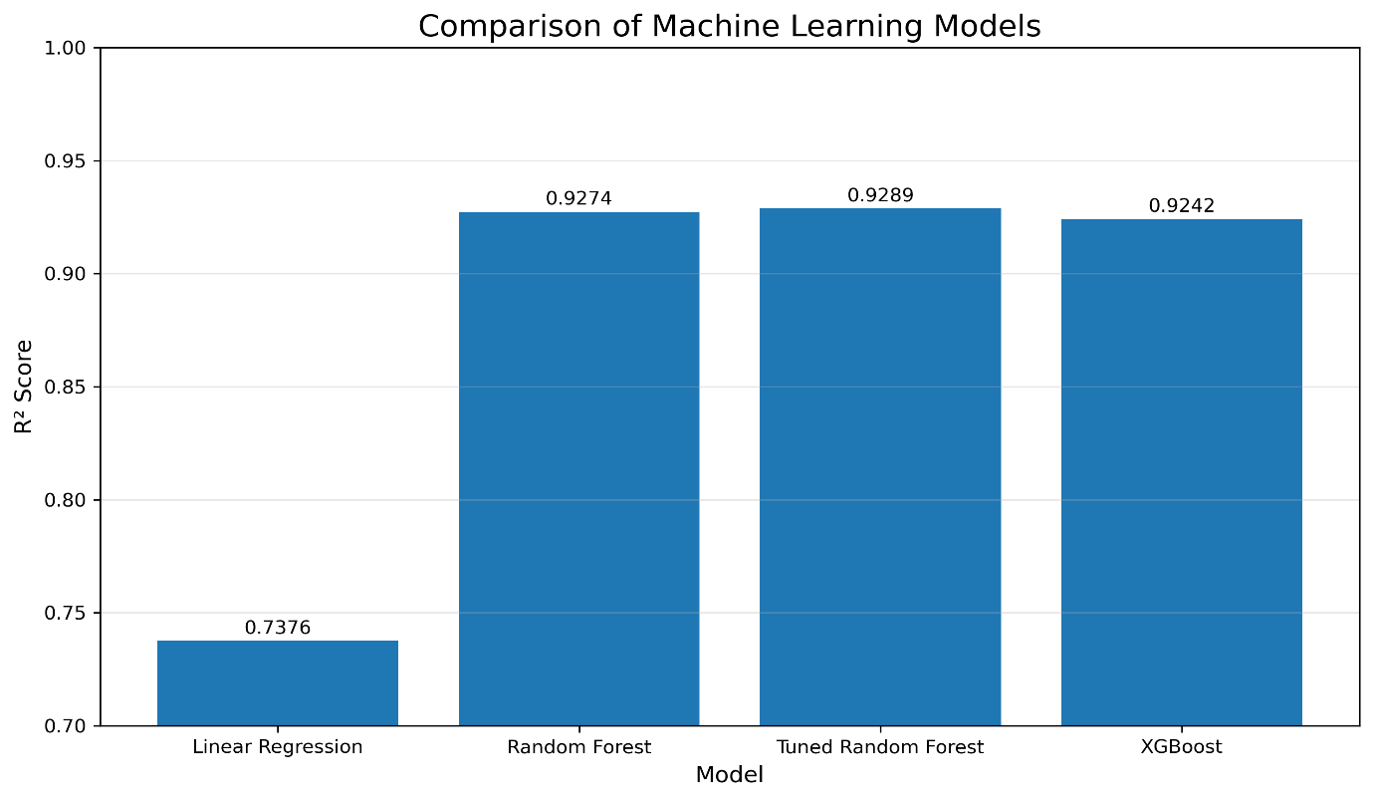
Figure 5. Performance Comparison of Machine Learning Models (R² Score).

The comparison clearly illustrates the superior performance of ensemble learning methods over the baseline Linear Regression model.
The optimized Random Forest achieved the highest coefficient of determination, closely followed by the standard Random Forest and XGBoost models. The relatively small performance difference between the ensemble models suggests that all three algorithms effectively capture nonlinear interactions among material descriptors.
Overall, the Tuned Random Forest model provides the best balance between predictive accuracy and model robustness, making it the preferred model for superconducting critical temperature prediction.

6.7 Actual versus Predicted Analysis
To evaluate prediction quality visually, the predicted superconducting critical temperatures were compared with the experimentally measured values.
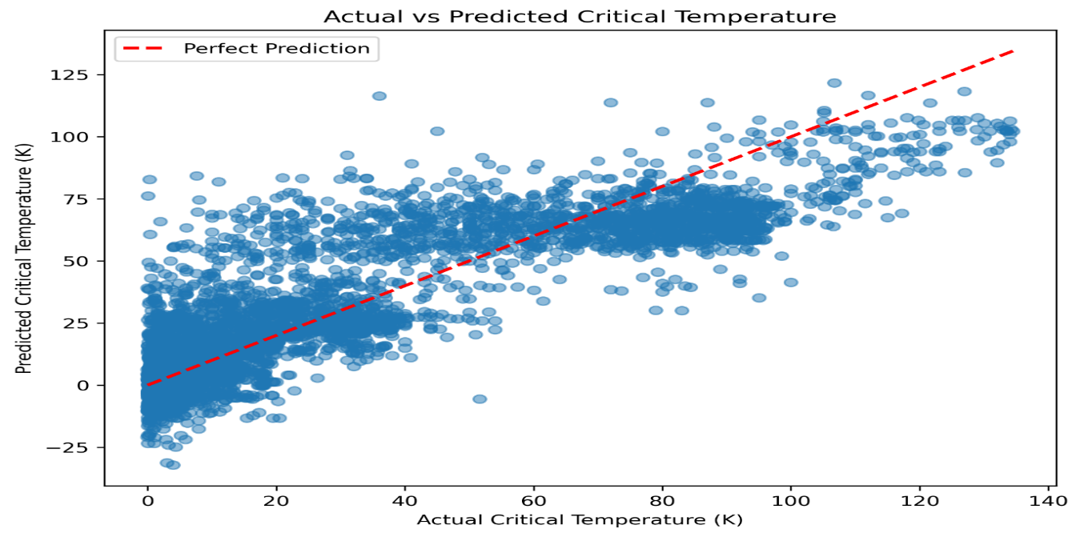
Figure 6. Actual vs Predicted Critical Temperature using the Tuned Random Forest Model.

The scatter plot demonstrates a strong agreement between predicted and observed critical temperatures. Most data points lie close to the ideal diagonal line, indicating that the optimized Random Forest accurately predicts the superconducting critical temperature across a broad range of materials.
Only a limited number of observations exhibit noticeable prediction deviations, suggesting that the model generalizes effectively to previously unseen samples.

6.8 Residual Analysis
Residual analysis was performed to further assess the predictive performance of the optimized Random Forest model. Residuals represent the difference between the observed and predicted critical temperatures.
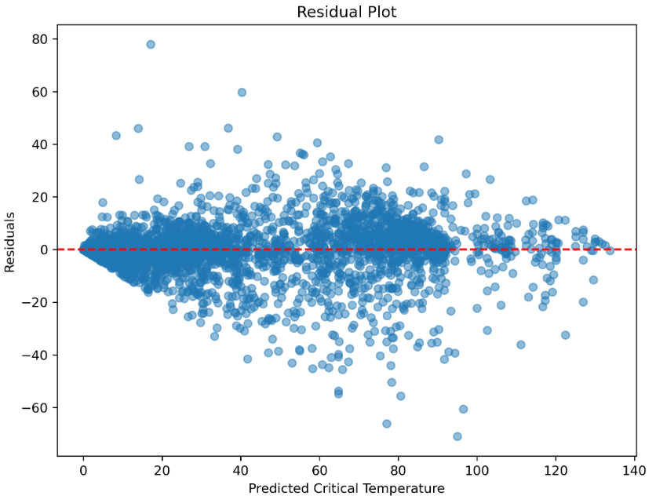

Figure 7. Residuals versus Predicted Critical Temperature.

The residuals are distributed around the zero-error line without a strong systematic trend, indicating that the model does not exhibit significant prediction bias. Although the spread of residuals increases slightly for intermediate and higher predicted temperatures, the majority of prediction errors remain centered near zero. This suggests that the optimized Random Forest model generalizes well across a wide range of superconducting critical temperatures while maintaining stable predictive performance.
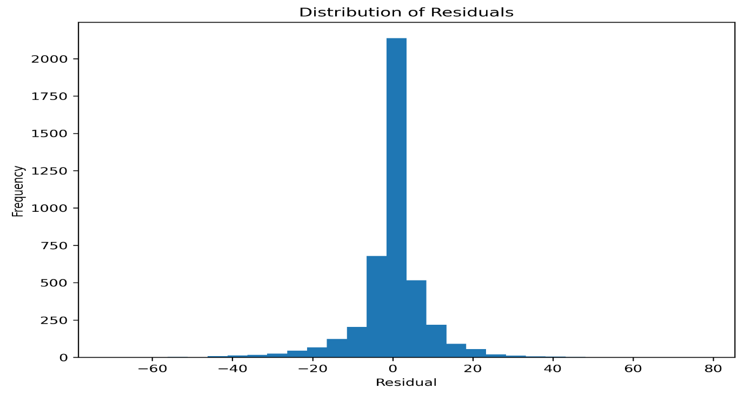
Figure 7. Distribution of Prediction Residuals.

The residual histogram is approximately centered around zero, indicating that positive and negative prediction errors are reasonably balanced. The absence of substantial skewness suggests that the model produces unbiased predictions for most samples.

7. Explainable Artificial Intelligence using SHAP
Although ensemble learning models provide excellent predictive performance, they often operate as black-box models whose internal decision-making processes are difficult to interpret.
To improve model transparency, SHapley Additive exPlanations (SHAP) were employed to quantify the contribution of individual material descriptors to the predicted superconducting critical temperature.
SHAP values are derived from cooperative game theory and assign each feature an importance value that represents its contribution to a particular prediction. This approach enables both global and local interpretation of machine learning models while preserving mathematical consistency.

7.1 SHAP Summary Plot
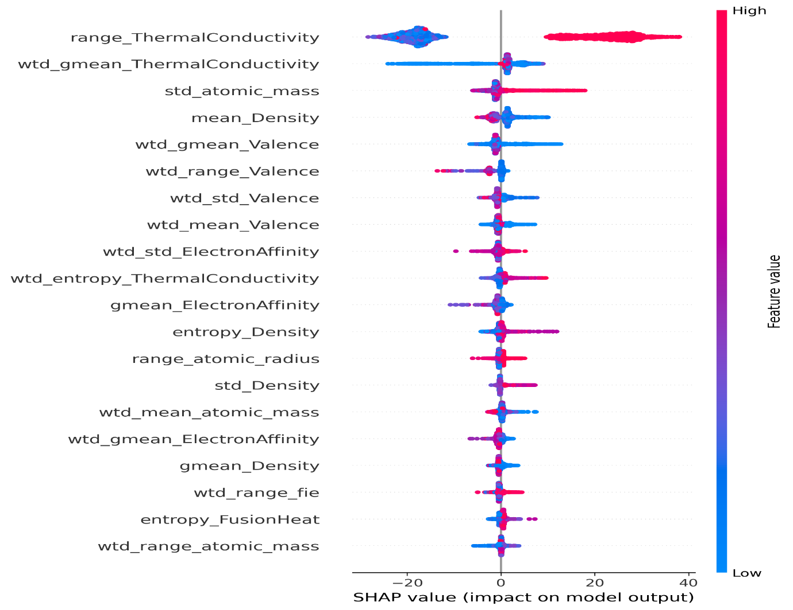
Figure 8. SHAP Summary Plot.

The SHAP summary plot provides a global overview of feature influence across the entire dataset.
Each point represents an individual material sample, while the color indicates the corresponding feature value. Features appearing at the top of the plot have the greatest influence on model predictions.
The summary plot reveals that thermal conductivity, atomic mass, density, valence-related descriptors, and several compositional features contribute most significantly to the prediction of superconducting critical temperature.
Furthermore, the wide distribution of SHAP values for these features indicates substantial variability in their influence across different materials, reflecting the complex nature of superconductivity.

7.2 SHAP Feature Importance
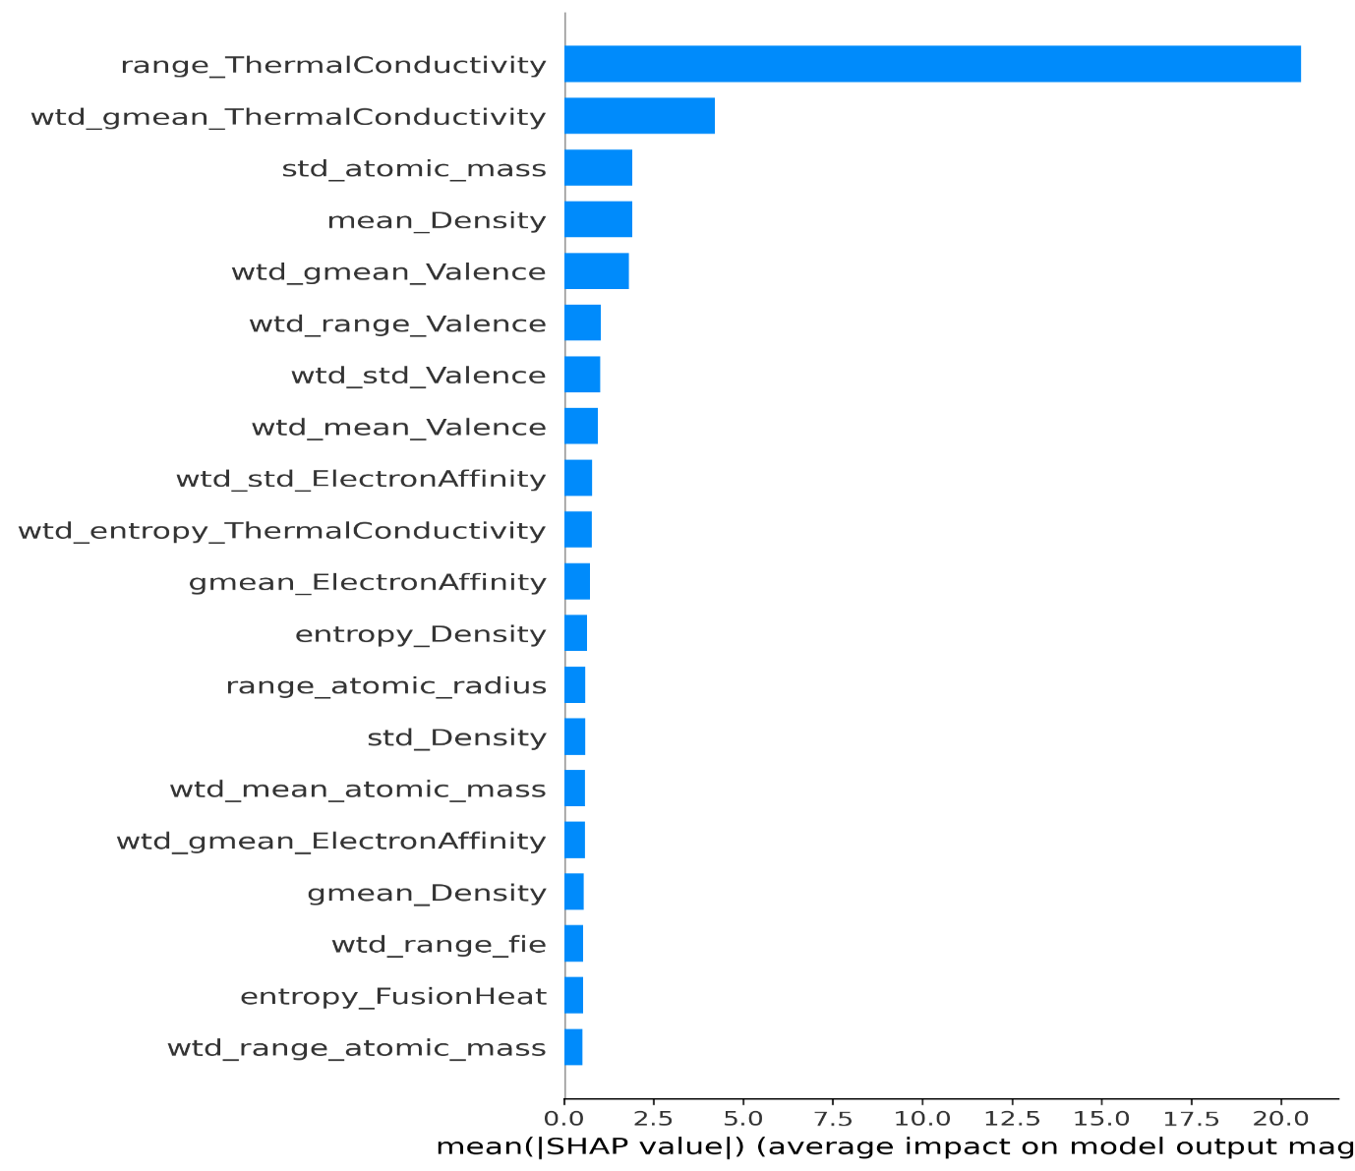
Figure 9. SHAP Feature Importance Plot.

The SHAP feature importance plot ranks material descriptors according to their average absolute contribution to the model predictions.
Unlike conventional feature importance obtained directly from Random Forest, SHAP provides a consistent and theoretically grounded interpretation of feature influence.
The results confirm that only a relatively small subset of descriptors contributes strongly to the prediction of superconducting critical temperature, whereas many remaining features exhibit comparatively minor influence.
This analysis improves confidence in the predictive model by demonstrating that its decisions are driven by physically meaningful material descriptors rather than arbitrary statistical correlations.

8. Discussion
The primary objective of this study was to investigate the effectiveness of machine learning techniques in predicting the superconducting critical temperature (Tc) of materials using experimentally measured material descriptors. Four regression algorithms—Linear Regression, Random Forest Regression, Tuned Random Forest, and Extreme Gradient Boosting (XGBoost)—were developed and systematically compared.
The experimental results clearly demonstrate that ensemble learning methods substantially outperform the traditional Linear Regression model. Linear Regression achieved an R² Score of 0.7376, indicating that although it captured the general trend of the dataset, its assumption of a purely linear relationship limited its predictive capability. The comparatively larger MAE and RMSE values further suggest that the superconducting critical temperature depends on complex nonlinear interactions among material descriptors that cannot be adequately represented by a simple linear model.
Random Forest Regression significantly improved predictive performance by learning nonlinear relationships through an ensemble of decision trees. The model achieved an R² Score of 0.9274 while considerably reducing prediction errors. Hyperparameter optimization further enhanced the Random Forest model, resulting in the highest predictive accuracy among all evaluated models with an R² Score of 0.9289 and the lowest RMSE of 9.0468. Although the improvement over the baseline Random Forest was modest, the optimized model demonstrated better generalization performance without increasing model complexity substantially.
The XGBoost model also exhibited excellent predictive capability, achieving an R² Score of 0.9242. Its performance was comparable to the optimized Random Forest model, confirming that gradient boosting algorithms are highly effective for modeling complex materials datasets. However, within the scope of this study, the Tuned Random Forest slightly outperformed XGBoost across the selected evaluation metrics, making it the preferred predictive model.
The results suggest that superconducting critical temperature is governed by highly nonlinear interactions among multiple material descriptors. Ensemble learning methods effectively capture these interactions by combining multiple decision trees, thereby improving prediction accuracy compared with conventional statistical models.
An important contribution of this work is the incorporation of Explainable Artificial Intelligence (XAI) through SHAP analysis. While ensemble learning models often provide excellent predictive performance, they are frequently criticized for functioning as "black-box" models. The SHAP analysis addressed this limitation by identifying the contribution of individual material descriptors to model predictions. Features related to thermal conductivity, atomic mass, density, and valence electrons consistently exhibited the greatest influence on predicted superconducting critical temperature. This not only enhances confidence in the developed model but also provides valuable scientific insight into the physical factors associated with superconductivity.
Overall, the integration of ensemble learning algorithms with explainable artificial intelligence demonstrates a practical and reliable computational framework for accelerating superconducting materials research. Such approaches can assist researchers in identifying promising candidate materials while reducing the dependence on expensive and time-consuming experimental investigations.

9. Conclusion
This research project presented a comprehensive machine learning framework for predicting the superconducting critical temperature of materials using experimentally measured material descriptors from the UCI Superconductivity Dataset.
A complete machine learning workflow was implemented, including data preprocessing, exploratory data analysis, model development, hyperparameter optimization, model evaluation, and explainable artificial intelligence. Four regression algorithms—Linear Regression, Random Forest Regression, Tuned Random Forest, and XGBoost—were trained and systematically compared using MAE, RMSE, and R² Score.
Among all evaluated models, the Tuned Random Forest achieved the highest predictive performance with an R² Score of 0.9289, demonstrating its ability to accurately capture complex nonlinear relationships between material descriptors and superconducting critical temperature. Random Forest and XGBoost also exhibited excellent predictive capability, significantly outperforming the baseline Linear Regression model.
The incorporation of SHAP explainability further strengthened the study by providing transparent interpretation of the model predictions. The analysis identified several material descriptors that strongly influence superconducting critical temperature, improving both the scientific interpretability and reliability of the developed machine learning framework.
The results demonstrate that machine learning, particularly ensemble learning methods combined with explainable artificial intelligence, provides a powerful computational tool for accelerating materials discovery. Such approaches have the potential to reduce experimental effort, improve prediction accuracy, and support future research in computational materials science.

10. Future Work
Although the developed machine learning framework achieved excellent predictive performance, several opportunities exist for further improvement and future research.
• Investigate Graph Neural Networks (GNNs) for learning structural relationships among superconducting materials.
• Develop deep learning models such as Artificial Neural Networks (ANNs) to further improve predictive performance.
• Explore Physics-Informed Machine Learning (PIML) approaches by incorporating physical constraints and domain knowledge into predictive models.
• Evaluate additional ensemble learning algorithms, including CatBoost and LightGBM, for comparative performance analysis.
• Apply advanced feature selection and dimensionality reduction techniques to improve computational efficiency while maintaining predictive accuracy.
• Extend the proposed framework to predict additional material properties such as thermal conductivity, electrical conductivity, elastic modulus, and band gap energy.
• Investigate uncertainty quantification techniques to estimate the confidence associated with machine learning predictions.
• Develop a Streamlit-based web application that enables users to predict the superconducting critical temperature through an interactive interface.
• Validate the proposed framework using newly synthesized superconducting materials to assess its real-world predictive capability.

11. References

[1] Dua, D., & Graff, C. (2019). UCI Machine Learning Repository. University of California, Irvine, School of Information and Computer Sciences.
[2] Breiman, L. (2001). Random Forests. Machine Learning, 45(1), 5–32.
[3] Chen, T., & Guestrin, C. (2016). XGBoost: A Scalable Tree Boosting System. Proceedings of the 22nd ACM SIGKDD International Conference on Knowledge Discovery and Data Mining, 785–794.
[4] Lundberg, S. M., & Lee, S. I. (2017). A Unified Approach to Interpreting Model Predictions. Advances in Neural Information Processing Systems (NeurIPS), 30.
[5] Pedregosa, F., Varoquaux, G., Gramfort, A., et al. (2011). Scikit-learn: Machine Learning in Python. Journal of Machine Learning Research, 12, 2825–2830.
[6] Harris, C. R., Millman, K. J., van der Walt, S. J., et al. (2020). Array Programming with NumPy. Nature, 585, 357–362.
[7] McKinney, W. (2010). Data Structures for Statistical Computing in Python. Proceedings of the 9th Python in Science Conference, 56–61.
[8] Hunter, J. D. (2007). Matplotlib: A 2D Graphics Environment. Computing in Science & Engineering, 9(3), 90–95.
[9] Van Rossum, G., & Drake, F. L. (2009). Python 3 Reference Manual. CreateSpace.
[10] Molnar, C. (2022). Interpretable Machine Learning (2nd ed.). Available at: https://christophm.github.io/interpretable-ml-book/

Acknowledgement
I would like to express my sincere gratitude to all the researchers and developers whose open-source datasets, software libraries, and scientific publications made this project possible. I am especially thankful to the developers of Python, Scikit-learn, XGBoost, SHAP, Pandas, NumPy, and Matplotlib for providing powerful computational tools that enabled this research.
I also acknowledge the UCI Machine Learning Repository for providing the superconductivity dataset used throughout this study.
Finally, I am grateful for the opportunity to apply concepts from computational physics and machine learning in addressing a challenging materials science problem. This project has significantly enhanced my understanding of data-driven scientific research and explainable artificial intelligence.
This project was independently conceived, implemented, and documented by the author as a self-directed research study.

